**Fayetteville State University ROTC HALL OF FAME BY-LAWS**

1. **PURPOSE:**

The Fayetteville State University (FSU) ROTC Hall of Fame honors those who have meritoriously served on active duty and who continue to serve by supporting the FSU Cadet program and the community at large. Prospective inductees include graduates of Fayetteville State University and its AFROTC partnership schools: Pembroke State University (PSU), Methodist University (MU), and Campbell University (CU) who completed the FSU ROTC program and distinguished themselves in military and/or civilian professions.

1. **CRITERIA:**

Eligibility for nomination and induction into the Hall of Fame are as follows:

a. Retired from active duty andbe a graduate of Fayetteville State University, or partnership / affiliate school **AND**

* + 1. Received a commission from the FSU ROTC Program or its partnership program(s) offered at Pembroke State University, Methodist University, and Campbell University, **OR**
    2. A graduate of FSU who received a commission through any other source (Navy, Officer Cadet School, Direct Commission, etc.), **AND**
  1. Attained the rank of Major or higher while serving on active duty, or in the Reserves, or in the National Guard, **OR**
  2. Elected or appointed to an office of prominence in the public or private sector, **OR**
  3. Obtained a position of prominence in the private sector, **OR**
  4. Recognized on a national or international level for outstanding achievement or service, **OR**
  5. Awarded the Medal of Honor, regardless of rank.
  6. Verified Killed in Action (KIA) while deployed to an approved hostile/hazardous duty area, regardless of rank.
  7. Served in an approved hostile/hazardous duty area regardless of rank.

1. **SOURCE OF NOMINATION(S):**

a.Original FSU ROTC Cadre Steering Committee and on-going HOF membership.

(Members may not necessarily be inductees but rather members of the FSU ROTC Cadre organization).

b. University and ROTC faculty

c. University Alumni

1. **NOMINATION PACKET:**

Nominations shall be submitted in an electronic PDF format, in order to facilitate transmission to committee members for early review and archiving. The following items are required:

* 1. Submit an electronic submission packet in PDF format, available by contacting the FSU ROTC Cadre Chair via website email.
  2. Nomination packet (*see website*) must include a one-page biography addressing the year of graduation, academic major, contributions, awards, and assignments. See attached example (Biography - ANNEX A).
  3. Submit a high quality color photo (in uniform) of the applicant in JPG format. (ex: Photo - ANNEX B).
  4. Hand written nomination packets are not acceptable.

1. **SELECTION COMMITTEE:**

The Selection Committee will meet during May of the selection year in order to select personnel for induction into the HoF during the fall semester. The committee will consist of representatives from each of the following areas, with no less than four (4) and no more than five (5) committee members:

a. Initial induction committee: Steering Committee Chair (FSU ROTC Cadre Secretary).

b. Three (3) or more FSU ROTC Cadre members.

1. **SELECTION PROCESS:** 
   1. Nominations will be made using the electronic PDF format Hall of Fame nomination form, mentioned in paragraph 4.
   2. Nominations received by the FSU ROTC HOF Committee prior to the May 10th of the calendar year deadline will be considered for induction during the upcoming fall school year.
   3. The Selection Committee will meet in May to select nominees for induction into the FSU ROTC Hall of Fame. The committee is not required to select any of the nominees if the committee does not feel that any of the nominees deserve to be selected.
   4. Committee members will ensure the nominees meet all of the criteria in accordance with paragraph 2.
   5. Each nominee packet must receive unanimous approval by all committee members in order to be inducted into the HoF. Any committee member [through anonymous vote] can disapprove a nomination packet. Likewise, any committee member can recommend a nomination packet be considered for induction into the Honorary HoF, in lieu of induction into the HoF proper.
   6. Personnel selected for induction will be notified via USPS mail no later than Memorial Day weekend. FSU ROTC HoF will provide the exact date, time, and location for induction into the hall of fame.
   7. Due to limited space inside the___________, no additional ROTC Hall of Fame inductees will be displayed on the walls with the silver framed photo and biography, but will be digitally displayed online.

1. **HONORARY INDUCTEES AND RECOGNITION:** 
   1. In 2024 the first honorary inductees will be enshrined in the FSU ROTC Hall of Fame. Future honorary inductees would be considered every five (5) years thereafter unless extenuating circumstances present themselves.
   2. In December 2021, the HoF Chair revised Honorary HoF criteria such that selection may be made each year as deemed appropriate by the HoF Chair with the support of the selection committee. There is NO requirement to induct personnel each year into the Honorary HoF, nor shall there be a limit to the number of personnel inducted, or any limit to the calendar year in which worthy candidates may be inducted.
   3. Selection criteria will be determined by FSU ROTC Cadre and the selection committee. Honorary HoF nomination packets must receive unanimous approval by the selection committee in order to be inducted.
   4. The process of recognizing honorary members will be standardized by the FSU ROTC Cadre Steering Committee, or by members appointed by the Cadre.
   5. Those who did not make it into the ROTC Hall of Fame on a given year but had a very strong submission packet would be considered for induction into the Honorary HoF the following year. Honorary inductees remain eligible to be resubmitted in the following year for the HoF Proper. If there is a resubmission of a person in the Honorary HoF to be competed for placement into the ROTC Hall of Fame Proper, and that resubmission is voted into the Hall of Fame Proper, that individual will be removed from the Honorary HoF and placed into the ROTC Hall of Fame Proper. If that individual is not voted into the ROTC Hall of Fame Proper, then that individual will remain in the Honorary HoF.
2. **Hall of Valor Inductees**

Individuals with distinguished military and or civilian careers. These individuals must meet the basic FSU ROTC HoF criteria to be considered for the Hall of Valor.

Criteria:

a. Have served in a position that commanded/directed resources that supported state, national, or international governance of national security.

b. Directed programs/organizations that impacted the well being of municipal, state, and national communities.

c. Developed organizations, inventions, systems, educational programs , culture programs, economic, and or social entities that greatly enhanced the nation and all humanity.

**ANNEX A – SAMPLE BIOGRAPHY**

***Lieutenant Colonel Greory M. Newton (USAF Retired)***

*Lieutenant Colonel Newton is a native of Raeford, North Carolina. He is a 1995 graduate from Fayetteville State University, where he earned his Bachelor of Science degree in Biology. He holds a Master’s of Science in Adult Education from Michigan State University.*

*LTC Newton’s previous assignments include duty in Hanau, Germany as an Aircraft Maintenance Officer and Executive Officer. While in Germany, he deployed three times to the former Yugoslavia, serving twice in Bosnia-Herzegovina and once in Albania. In 2001 he served as the Wing Maintenance Operations Plans Officer in Seoul, Korea. He returned to the US and was assigned to Nellis Air Force Base, Neveda were he assumed Command of 99th Contracting Office. From there he was deployed to Iraqi as the Onsite Contracting Officer for the region. Upon his return to Nellis Air Force Base and completion of that assignment he took his second command as the 332nd Chief of Aircraft Maintenance at Ramstein Air Base, Germany. Following that assignment he attended Air War College at Maxwell Air Forces Base, Montgomery, Alabama. After completion of Air War College LTC Newton was assigned as the Recruiting Commander for the Southeast Division. Upon completion of this command, LTC Newton assumed duties as the Professor of Aero Science at Mobely State University in May 2011.*

*His awards and decorations include two Bronze Star Medals, two Air Force Meritorious Service Medals, the Air Medal, four Air Force Commendation Medals, two Air Force Achievement Medals, the Air Force Reserve Component Achievement Medal, two National Defense Service Medals, the Armed Forces Expeditionary Medal, the Kosovo, Afghanistan, and Iraq Campaign Medals, Global War on Terrorism Expeditionary and Service Medals, the Korean Defense Service Medal, the Armed Forces Service Medal, the Humanitarian Service Medal, five Overseas Service Ribbons, the NATO medal, and the Parachutist, Recruiter, Air Assault, and Parachute Badge.*

*Lieutenant Colonel Newton is married to his beloved wife Theresa and they have three children, Michael, Belinda, and Kara. His family currently resides in Santee, South Carolina.*

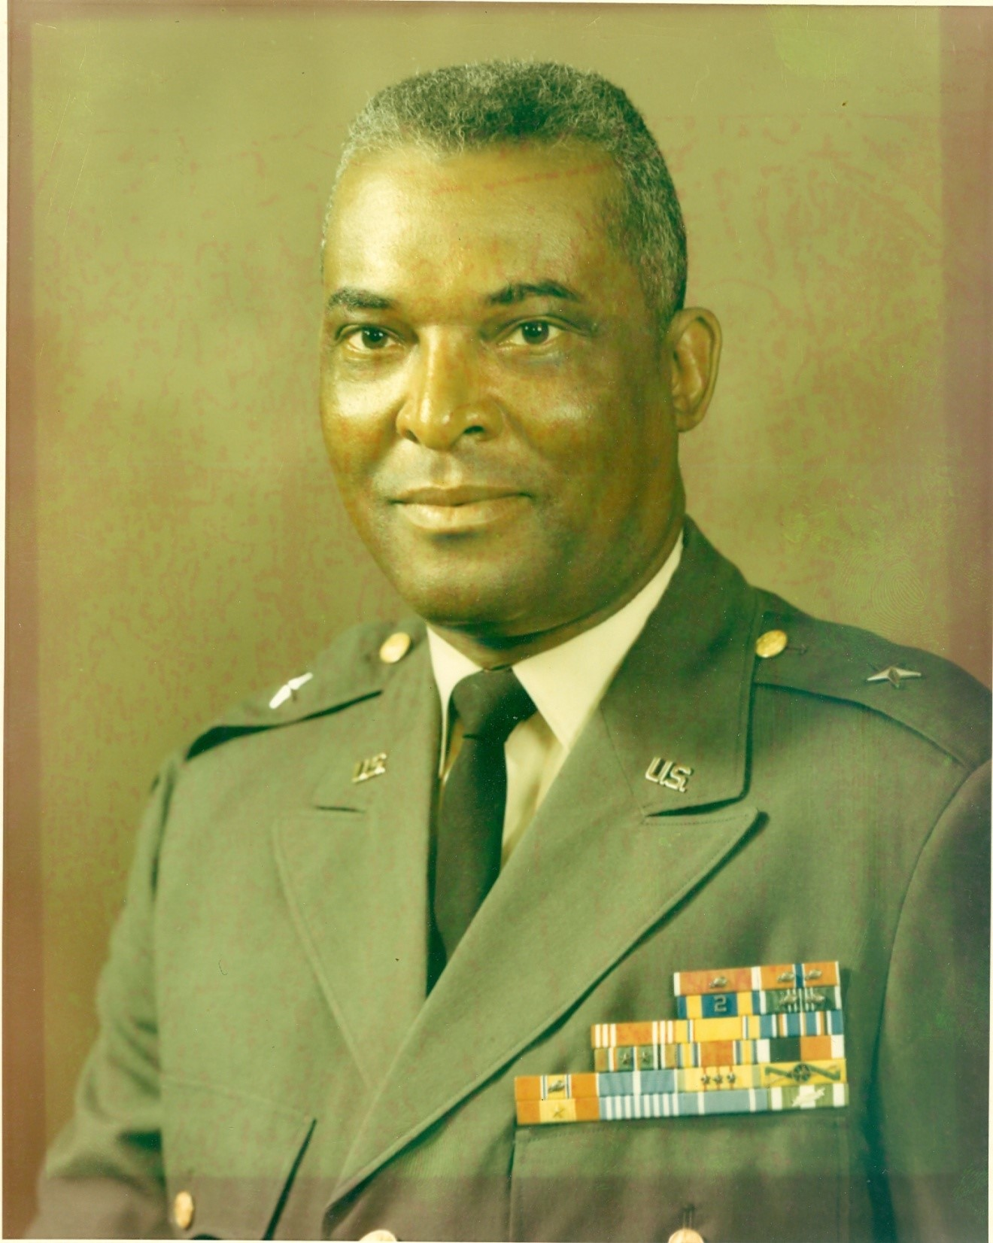

*ANNEX B – SAMPLE PHOTO* Provide photo (JPEG) or a quality photo 5” x 7” or larger. Command or DoD style photos are highly recommended (see above).